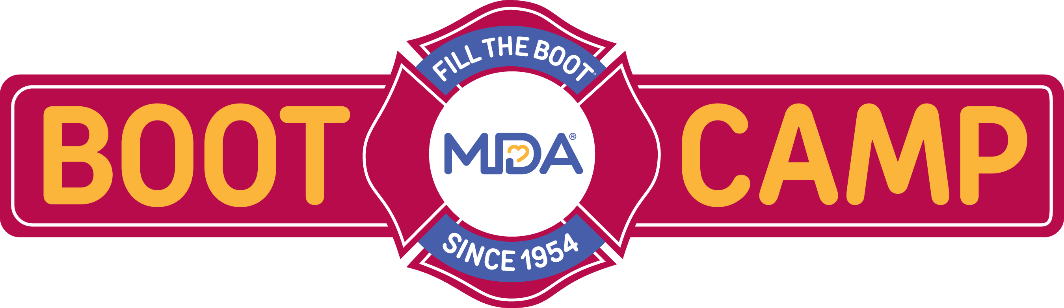

REGISTRATION FORM

Thursday, March 29, 2018

Mohegan Sun Resort and Casino

1 Mohegan Sun Blvd.

Uncasville, CT 06382

PLEASE RETURN THIS FORM by March 16, 2018 to:

Albany NY fax (518) 453-1477 email Joelle at jcarroll@mdausa.org
Syracuse NY fax (315) 451- 4107 email David at dciesielski@mdausa.org
Rochester/Buffalo NY fax (585) 424-1446 email Alicia at asinicropi@mdausa.org
Metro NY fax (212) 358-1068 email Stacie at sspitzkoff@mdausa.org

Local #___________Department or Local Name/City________________________ will be attending the 2018 MDA Boot Camp.

Names of representative(s) attending (please fill out completely):
Name: | Name:
Email: | Email:
Address: | Address:
City/Zip: | City/Zip:
Phone: | Phone:
Cell: | Cell:

AGENDA
11:00am – 12:00pm Registration
12:00pm – 1:00pm Lunch
1:00pm Boot Camp – reception to follow

Questions: Call your local MDA office at for more information. Albany (518) 489-5495 Syracuse (315) 451-8269 Rochester/Buffalo (585)424-6560 Metro NY (212) 358-1012
_{Join the Fun! Don’t Miss It!}

