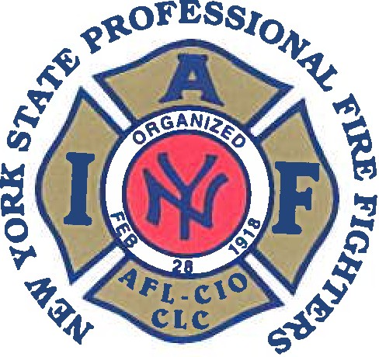

SAMUEL A. FRESINA
President

JAMES J, MCGOWAN
Secretary-Treasurer

EXECUTIVE BOARD
Executive V.P.
DAVID J. HOLLERAN

1st District V.P. SEAN MCCABE
Ridge Road
Local 3794

2nd District V.P. TOM CARCONE
Syracuse Local 280

3rd District V.P. ANDY HIRSCH
Albany
0
Local 2007

4th District V.P. CHRISTOPHER
PUTNEY
Elmira
Local 709

5th District V.P.
SEAN DENIGRIS
New Rochelle
Local 628

7th District V.P.
LEROY MCGINNIS
New York City Local 94

8th District V.P. JAMES MCCARTHY
New York City Local 854

CHAPLAIN

REV JOHN TALLMAN
40 Collins Place
Albany, NY 12208
New York State Professional Fire Fighters Association, Inc.
174 Washington Avenue, Albany, NY 12210
Phone: 518-436-8827 • 1-800-238-8827 • Fax: 518-436-8830
E Mail: profire@nyspffa.org www.nyspffa.org

Dear [Dignitary]:

The New York State Professional Fire Fighters have long advocated for the appropriate number of fire fighters and EMS personnel, as well as mobile resources to assure safe, efficient, and effective operation on the scene of a fire or medical emergency. We are nationally recognized for our efforts to build an emergency response system that delivers time critical response to a citizen's call for help. Our success, in large measure, is attributable to your strong support and assistance.

We are very proud to invite you to the NYS Professional Fire Fighters Association Fire Ops 101. This one- day event, which will be held on May 15th and will feature the latest developments in Emergency Medical Services, Emergency Response and Fire Suppression.

We have invited elected public officials and representatives of the media. The event will be held at the Colonie Training Center - 108 Wade Rd. Latham, NY will run from 8 a.m. to 2 p.m.

This program will include suiting up in fire fighter protective clothing, wearing self-contained breathing apparatus and going inside a real fire to experience first-hand the environment in which fire fighters work. Obviously, this will be a controlled situation, but will nevertheless provide an opportunity to see and feel what fire fighters deal with on a daily basis. It promises to be a very exciting and informative day. We would be honored if you would consider participating in this activity. We believe this will provide you a perspective on our issues as never seen before. Additionally, the NYSPFFA will assure press coverage so that your constituents know you’re on the front line with us.

We sincerely hope that you can attend the one-day Fire Ops 101. As always, we appreciate your support. Please respond by April 30.

Any questions please contact President Sam Fresina at 518.365.3746 or Secretary/Treasurer Jim McGowan at 917.886.6948 and we will send you additional information.

James McGowan
Secretary/Treasurer

Samuel A. Fresina
President

AFFILIATED WITH INTERNATIONAL ASSOCIATION OF FIRE FIGHTERS IAFF, AFL, CIO, NEW YORK STATE - AFL-CIO

