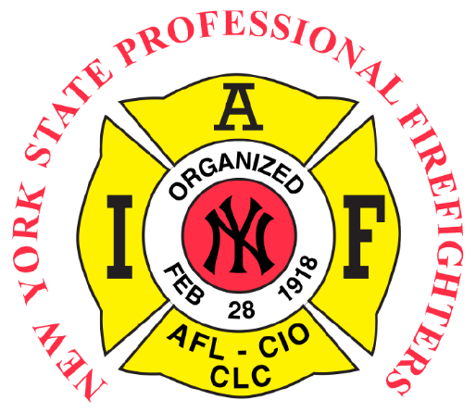

83rd Biennial NYSPFFA Convention
Kick Off Golf Tournament
Monday June 16th, 2025
Indian Hills Golf Course
1959 Indian Hills Rd
Painted Post, NY 14870

4 person Captain and Crew
Registration starts at 11 AM
Shotgun start at 12 PM
Food at the turn
50/50 raffle

$125 per golfer/ $500 per team
Hole sponsors available for $125 each
First come, first serve
Sign up for golf and sponsorships by emailing
Joe Heverly at smokinjoe531@gmail.com

Payments made out to “Elmira Local 709”
Mail payments to:
Elmira Firefighters Local 709
101 W 2nd St
Elmira NY 14901

